

**COMSATS University Islamabad, Lahore Campus**

**Subject**:

Object Oriented Programming.

**Submitted to:**

Sir Shahid Bhatti

**Submitted by**:

Hamdan Zulfiqar (SP24-BSE-032)

**Section**:

‘A’

**Student Form.**

**Mian File:**

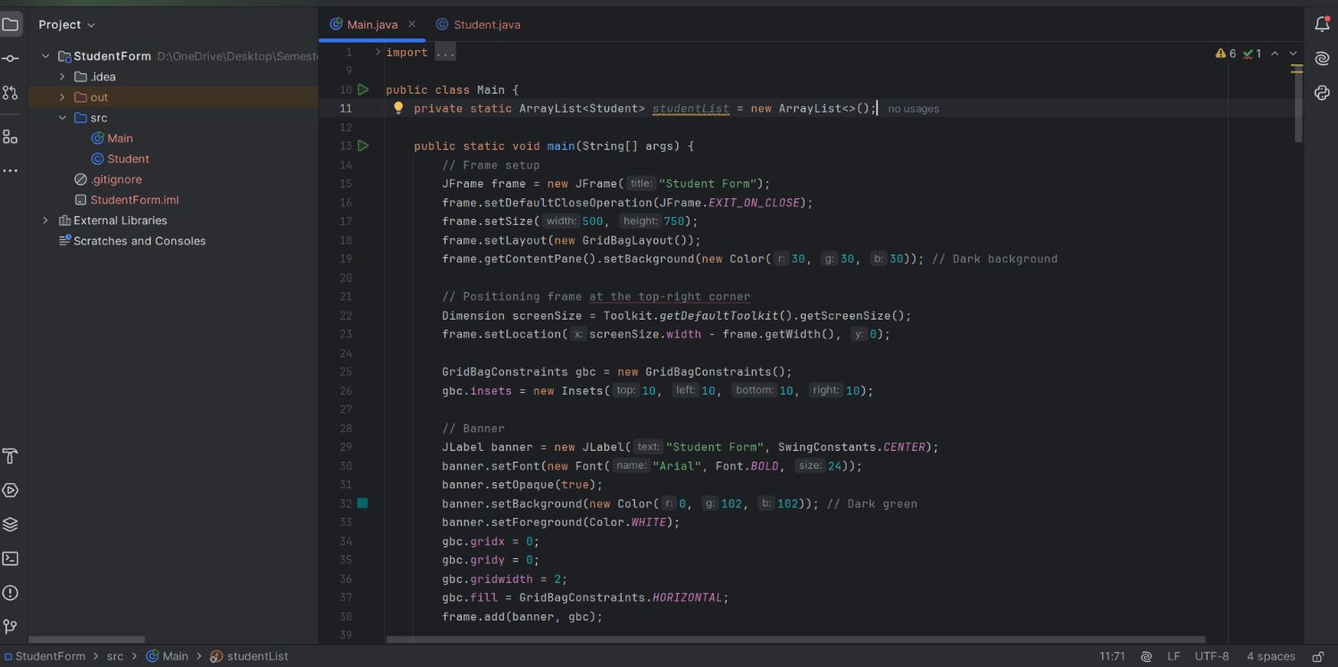

In main.java file, the code creates a graphical user interface **(GUI).** This program makes a simple student registration form with various fields, buttons, and features.

**Student Class:**

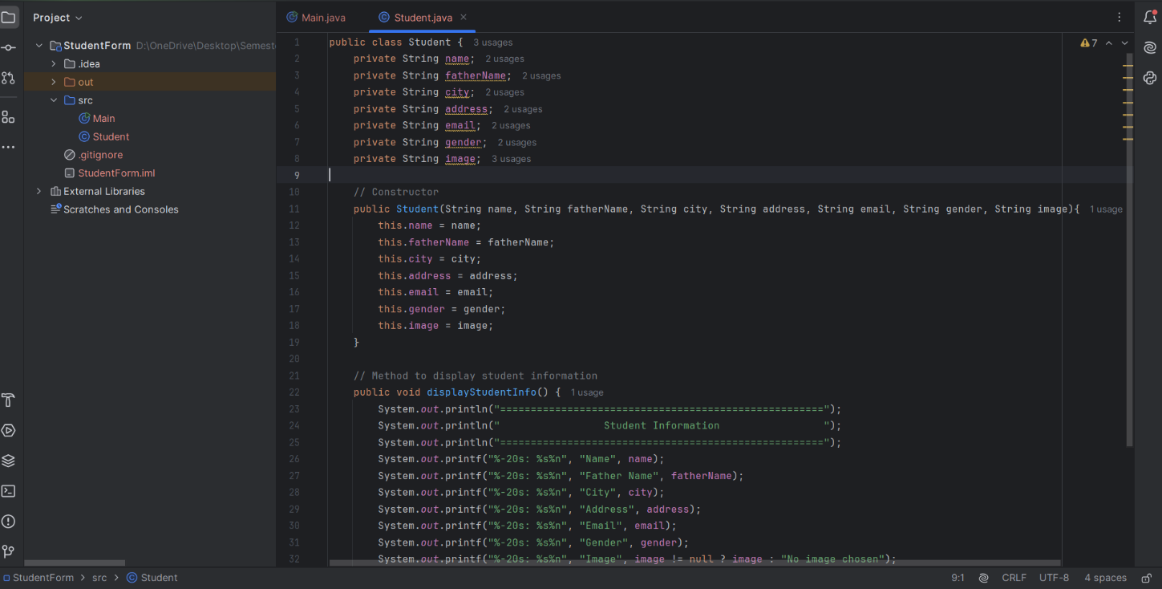

The student class is a simple Java class designed to represent a student's information with key features like attributes, constructor and a display info method to display the student information.

**Display of the Student Form:**

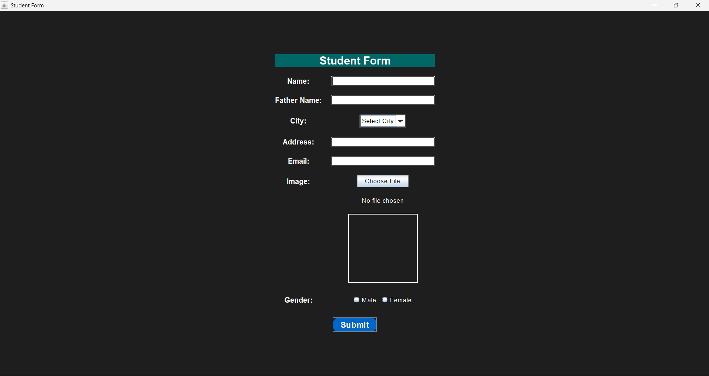

In this form, we can enter the name of the student, Father name, the city, address, email of the student and the image chosen by the student, along with gender. After entering the information, Click the submit button to submit the information.

**Filling the Information:**

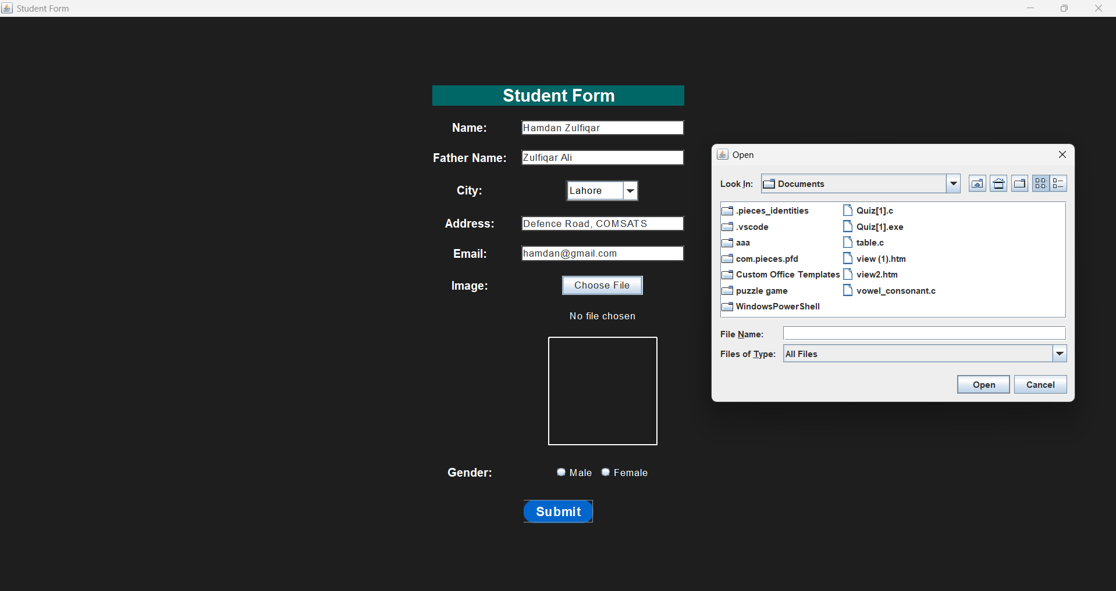

Fill the information, and for the image, click on the **Choose File** option, the file chooser dialog will get opened. Choose the image file you want to add in the form.

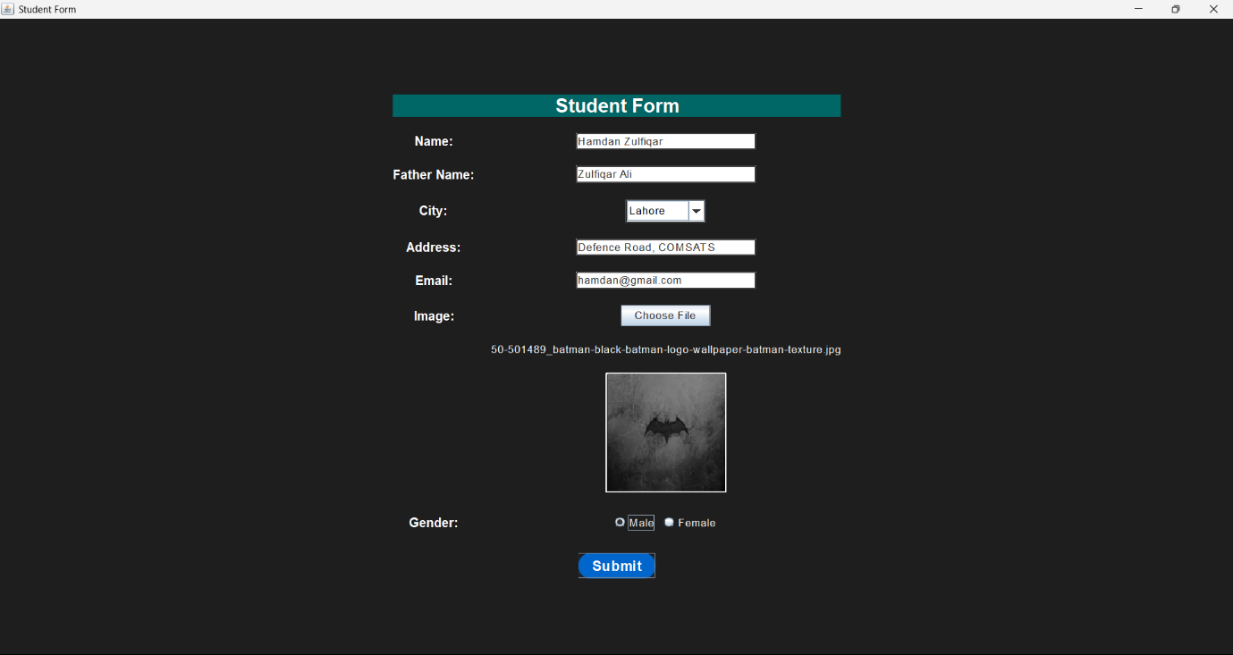

After choosing the image file, the image will be displayed on the student form.

**Submit Button:**

Click on the submit button for the data to be submitted successfully in the console.

**Display of Student Info in Console:**

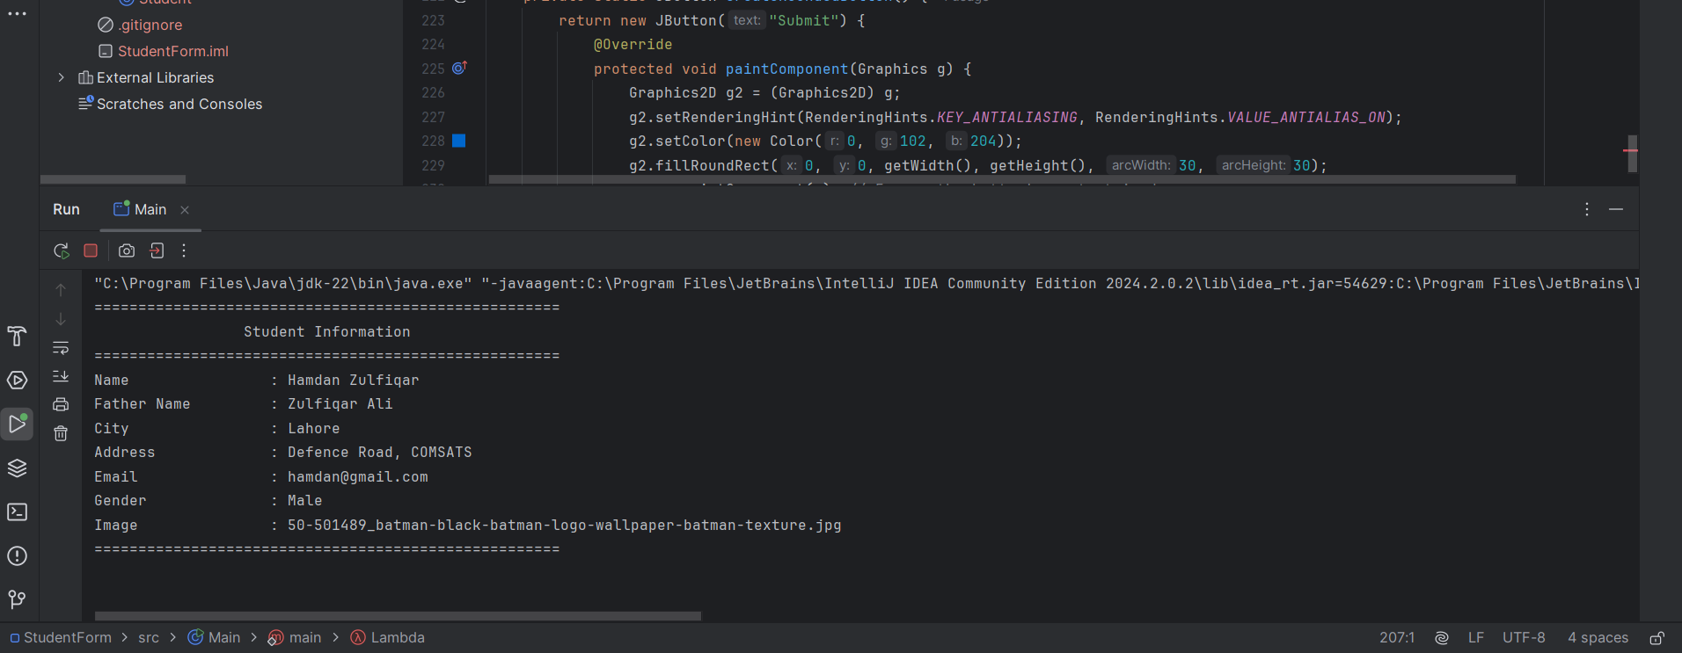

After the submission of data, the Student Info will be displayed in the terminal/console.

**Submission of data is Compulsory:**

In case of submission of incomplete form, error will be displayed.

**Choosing Image is Optional:**

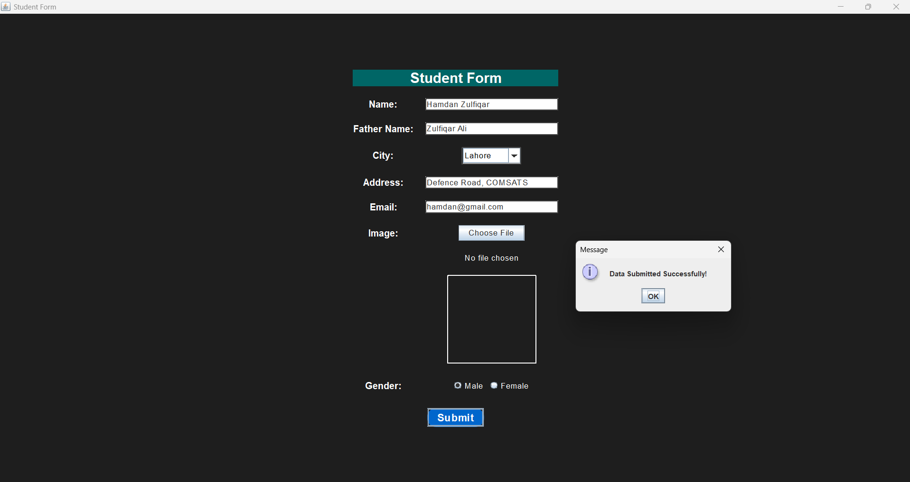

If the image is not selected, the data will successfully get submitted.

The following information will be displayed in the console:

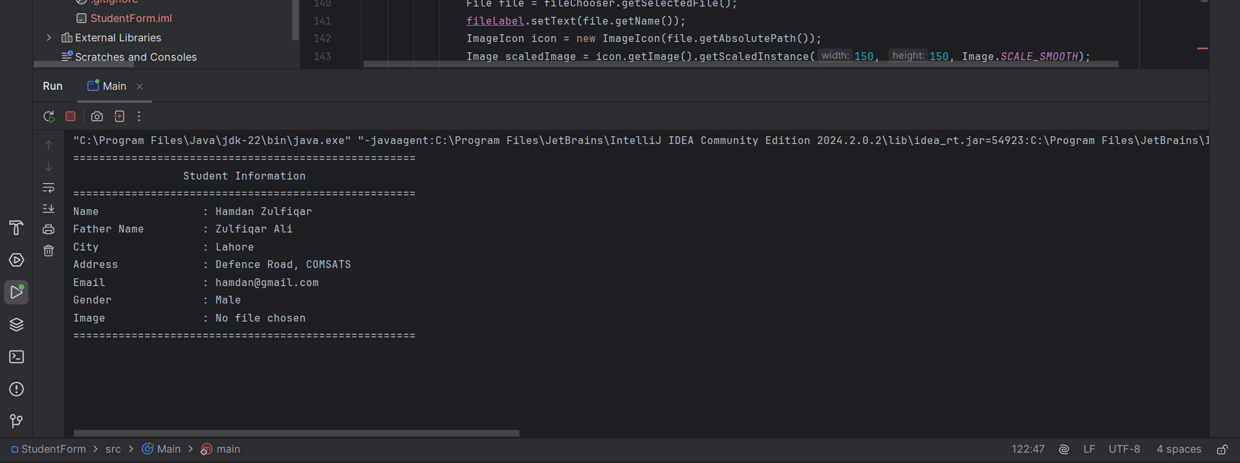

**THE END.**